

# Experiment Report One

Course Name: Operating System

Experiment Name: Adding A System Call to Kernel

Student Name: 李添豪

Student ID: 5140309349

Class Number: F1403015

## Experiment Environment

Operating System: Ubuntu LTS 16.04 (based on VMware)

Kernel Version: 4.4.6

## Experiment Target

Adding a system call to Linux kernel and call it via a C program.

## Experiment Procedure

Hint: For different Version of Linux kernel, there is different system file, that means if you use a different version of Linux Kernel, procedure below may not fit your system.

1. Download Linux kernel from [www.kernel.org](http://www.kernel.org)
2. Adding a system call number to the system call table:
   1. sudo gedit linux-4.4.6/arch/x86/entry/syscalls/syscall_64.tbl via CIL



* 1. Add your system call at the last of the file.



1. Adding a declaration to system call header file.
   1. sudo gedit linux-4.4.6/include/linux/syscalls.h via CIL



* 1. Adding the declaration of your system call at the end of the file



1. Implement of the System Call
   1. sudo gedit linux-4.4.6/kernel/sys.c



* 1. Adding the implement of your system call at the end of the file.

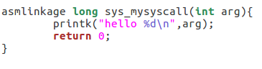

1. Compile the kernel and install

Command:

make oldconfig

make -j8

sudo make modules_install

sudo make install

sudo reboot

Hint: this may take you about 1 hours or so, please be patient.

After the system reboot, you can use command “uname -r” to check the kernel version.



1. Write a C file to call the system call

Code:

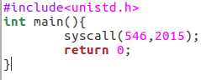

Compile the code and run it. Then you can use command: dmesg | grep “hello”to check your program.

